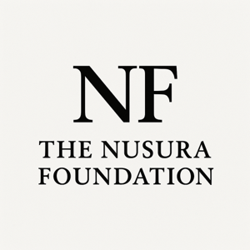

PRACTICUM INTEREST FORM

Thank you for your interest in completing your practicum with The Nusura Foundation. We are a public education and research-informed organization committed to addressing systemic inequities, including anti-Black racism, through community engagement, policy dialogue, and knowledge mobilization. Practicum placements are structured, supervision-based, and aligned with institutional learning objectives.

Student Information
Full Name:
Email:
Phone:
University:
Program:
Year of Study:
Practicum Start Date: End Date:
Total Required Hours:

Academic Focus

Area of concentration:
Relevant coursework completed:

Skills & Experience
Literature reviews
Academic writing
Policy analysis
Community engagement
Qualitative research
Quantitative research
Data analysis software (specify): _____________________________
Briefly describe relevant experience (200–400 words):

Learning Objectives

What are your learning goals for this practicum?

How does this practicum align with public education and systemic change?

University Requirements
Name of Practicum Liaison (if assigned):
Registered professional supervisor required? Yes No
Reporting requirements (if applicable):

Statement of Interest

Please provide a statement (300–500 words):

Acknowledgement

I understand that practicum placements are subject to review, supervisory capacity, and alignment with organizational priorities.
Submission Instructions

Please submit the completed Practicum Interest Form and supporting documents (e.g., resume, practicum guidelines) to:
Email: admin@nusurafoundation.com
Subject Line: Practicum Application – [Your Full Name]
Applications are reviewed on a rolling basis.

