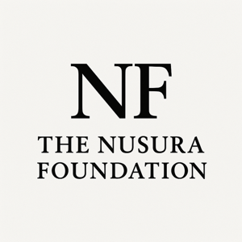

VOLUNTEER INTEREST FORM

Thank you for your interest in supporting The Nusura Foundation. We are a public education and research-informed organization committed to addressing systemic inequities, including anti-Black racism, through community engagement, policy dialogue, and knowledge mobilization. We review volunteer submissions on a rolling basis and will follow up where there is alignment with current needs and capacity.

Contact Information

Full Name:
Email:
Phone:
City / Province:

Areas of Interest (Check all that apply)

Event support
Research assistance
Policy research
Community outreach
Communications / Social Media
Administrative support
Fundraising
Graphic design
Other: ________________________________

Skills & Experience
Literature reviews
Report writing
Note-taking/meeting summaries
Data entry
Event coordination
Social media management
Canva / graphic design
Grant research
Community engagement

Briefly describe relevant experience (150–300 words):

Languages spoken (if applicable):
Professional background or field of study:

Availability
Hours per week available:
Short-term project Ongoing support

Motivation & Alignment

Why are you interested in volunteering with The Nusura Foundation? (200–300 words)

Orientation Acknowledgement

I understand that selected volunteers will be required to complete an orientation before starting their roles.

Please submit the completed form to admin@nusurafoundation.ca

