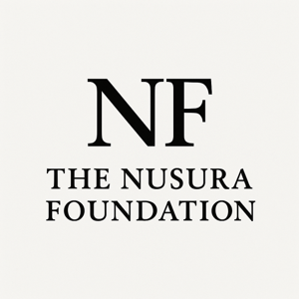

PARTNERSHIP & COLLABORATION INQUIRY FORM

The Nusura Foundation works alongside organizations, institutions, and community partners to design and deliver education-based initiatives focused on prevention, accountability, and public learning.

If you are interested in collaborating on a project, event, or initiative, please complete the form below. Submissions are reviewed on a rolling basis.

Organization Information

Organization Name:
Contact Person:
Title/Role:
Email:
Phone:
City / Province:

Organization Overview
Briefly describe your organization’s mission and work (150–250 words)

Type of Collaboration
Check all that apply:
Public education event
Workshop or training
Research collaboration
Policy dialogue or consultation
Community initiative
Program development
Other

Proposed Initiative

Please describe the initiative you are proposing. (200–400 words)
Include:
- Purpose of the initiative
- Intended audience
- Expected outcomes

Languages spoken (if applicable):
Professional background or field of study:

Resources & Support

Is funding available for this initiative?

Yes
No
To be determined
If yes, please describe available resources:

Alignment

How does this initiative address systemic inequities or contribute to public learning?

Additional Information
Anything else you would like us to know?

Please submit the completed form to admin@nusurafoundation.ca

